Subject: Important Information About Ohio Core Curriculum and Graduation Requirements

Dear Parent/Guardian, Adult Students, Foster Care Givers,

The Board of Directors of the Focus Schools has approved a resolution regarding Ohio Core curriculum requirements and high school graduation standards, in accordance with Ohio Revised Code 3313.6014.

All students must complete the Ohio Core curriculum to meet state graduation requirements. Failure to complete these requirements may result in a student being ineligible for admission to most Ohio public universities unless additional coursework is completed.

We encourage you to review your child's academic progress and consult with guidance counselors for planning and course selection. For more information, please refer to the student handbook, visit our school website, or contact your child’s Academic Adviser directly.

Thank you for your continued partnership in supporting your child's education.

Respectfully,
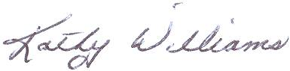

Kathy Williams
Superintendent
Focus Learning Academies
Focus North High School

